**In-class Exercise**

Write SQL queries for the following:

1. List FIRST_NAME and LAST_NAME of the vendors. (limit rows = 15) (10 points)

“select vendor_contact_first_name, vendor_contact_last_name

from vendors

where rownum <= 15;”

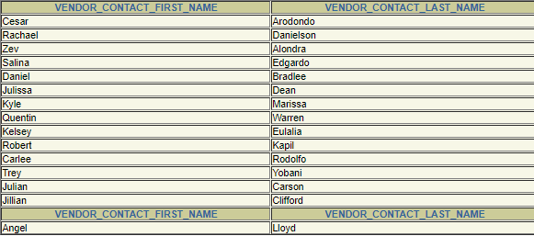

1. List the invoice_ID, vendor_id, and invoice_total values from the invoices table where invoice_total is greater than 2000. (20 points)

“select invoice_id,vendor_id,invoice_total

from invoices

where invoice_total > 2000;”

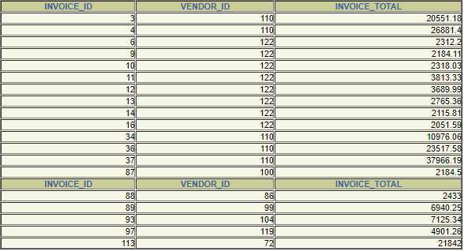

1. List the employees_NAMEs along with their department name. (20 points)

“ select first_name, last_name, department_name

from employees, departments

where employees.department_number = departments.department_number; “

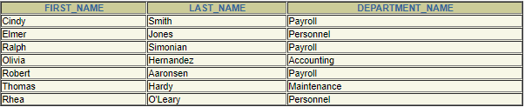

1. List all vendors with their address(city, state,zipcode) for all the vendors whose account has been credited (credit_total>0) (20 points)

“select vendor_name, vendor_address1, vendor_address2, vendor_city, vendor_state, vendor_zip_code

from vendors, invoices

where invoices.vendor_id = vendors.vendor_id and invoices.credit_total > 0;”



1. List the vendor_names and address(city, state,zipcode), invoice_total for all the vendors who have active invoices along with those that do not have active_invoices. [Hint: Use Outer Join] [active_invoices in ex_tables.sql] (limit rows = 15) (20 points)

“select vendor_name, vendor_address1, vendor_address2, vendor_city, vendor_state, vendor_zip_code, invoice_total

from vendors LEFT JOIN active_invoices

on active_invoices.vendor_id = vendors.vendor_id

where rownum <= 15;”

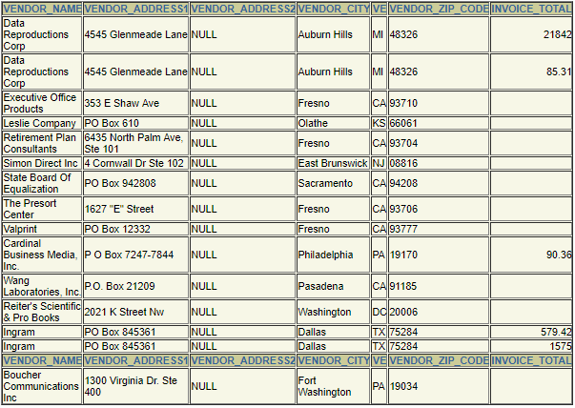

1. List the vendor_names and address for all the vendors who have active invoices. And the invoice_total in active_invoices table is not less than 1000 (10 points)

“select vendor_name, vendor_address1, vendor_address2

from vendors, active_invoices

where active_invoices.vendor_id = vendors.vendor_id and active_invoices.invoice_total > 1000;”

